Computer Language Coding Concepts

Relation Synchronization in a Diagram
The concept of relation synchronization is explained in the article Relation Synchronization. There isn’t really a display of relation synchronization in a diagram. You just know, that when a dual relation is expressed, the relation will be synchronized.

The procedures of relation synchronization are part of the system interface of symbols. System interfaces are the inner workings of symbols. The procedures of relation synchronization can be expressed in the diagram, if the system interfaces of the symbols are displayed. See the article System Interface.

This article shows diagrams to demonstrates the difference between not synchronizing two unary relations and synchronizing two unary relations.

Two unary relations will not be synchronized to eachother. An object of Class A can refer to an arbitrary object of Class B, which refers to an arbitrary object of Class A again.

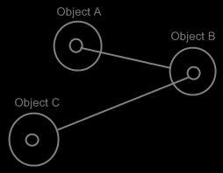

It doesn’t make the two objects refer to eachother. It just makes the two objects refer to an arbitrary object of the other class, but not necessarily to eachother.

For this, relation synchronization is applied, so that the first object and the second object always refer to eachother.

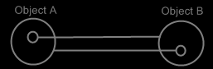

When the two following unary relations are synchronized,

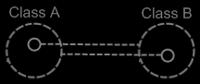

then the two class lines merge together, to form the picture below:

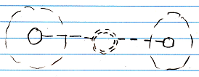

Relations between individual objects also turn from this:

Into this:

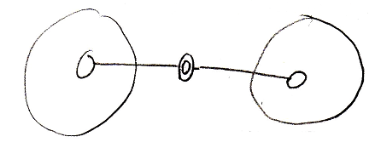

See also: Relation Synchronization, Relations in a Diagram, Relations Between Objects in a Diagram, System Interface

Author & Copyright: Jan-Joost van Zon Date: May 21, 2008 – June 18, 2008 Location: Oosterhout, The Netherlands Status: Finished

